User Requirement Specification
FOR
Volunteer Management System
(VMS)

CLIENT | The ClientThe Client
PROJECT | Volunteer Management System (VMS)
TITLE | User Requirement Specification
VERSION | 1.0
DATE | 02 Apr 2011
 | ORIGINATOR
 | Name / Signature | Hnin Nu Aye and Thida Khin Myo Thaung
 | APPROVAL
 | Name / Signature | Phung Kim Cuong, Dio
Institute of Systems Science |  | Document Reference
25 Heng Mui Keng Terrence  Singapore 119615 |  | VMS/T-1.2/1

 | Acceptance
 | Customer Signature |  | Customer Signature
 | Name & Designation |  | Name & Designation
 | Date & Company Stamp |  | Date & Company Stamp

Revision History

Date | Version | Description | Author
02 Apr 2011 | 1.0 | Initial release | Hnin Nu Aye and Thida Khin Myo Thaung

Table of Contents

1. INTRODUCTION 4
1.1 Background 4
1.2 Objectives 4
1.3 Organisation 4
1.4 Scope 4
1.5 Definition of Terms 4
2. OVERVIEW OF REQUIREMENTS 5
2.1 Introduction 5
2.2 System Perspective 5
2.3 System Functions 5
2.4 User Characteristics 7
2.5 General Constraints 7
2.5.1 Software Limitations 7
2.5.1.1 Server 7
2.5.1.2 Client 7
2.5.1.3 Development 7
2.5.2 Hardware Limitations 7
3. FUNCTIONAL REQUIREMENTS 8
3.1 Processing Requirements 8
3.1.1 Login 8
3.1.1.1 Login 8
3.1.2 Volunteer Management 9
3.1.2.1 Register Volunteer Account 9
3.1.2.2 Update Volunteer Profile 10
3.1.2.3 Forget Password 11
3.1.2.4 Change Password 11
3.1.2.5 Browse for Project 12
3.1.2.6 Raise Interest to Project 12
3.1.2.7 Review Project Interest by volunteer and Assign Volunteer to Project 13
3.1.2.8 Post Feedback to Project 14
3.1.2.9 Post Experience or Inspiring Stories 14
3.1.2.10 Review and Reply Feedback 15
3.1.2.11 Request for Certificate 15
3.1.2.12 Manage Volunteer Account 15
3.1.3 Staff Management 16
3.1.3.1 Register Staff Account 17
3.1.3.2 Update Staff Profile 17
3.1.3.3 Forget Password 18
3.1.3.4 Change Password 18
3.1.3.5 Manage Staff Account 19
3.1.4 Project Management 20
3.1.4.1 Propose Project 20
3.1.4.2 Review and Reply Project Proposal 21
3.1.4.3 Setup Project Details 21
3.1.4.4 Manage Projects 22
3.1.4.5 Review Project Interest by Volunteer and Assign Volunteer to the Project 23
3.1.4.6 Assign Roles to Project Member 23
3.1.4.7 Setup Project Calendar 23
3.1.5 Itinerary Management 24
3.1.5.1 Prepare Itinerary Plan 24
3.1.5.2 Submit Itinerary Plan 25
3.1.5.3 Review and Reply Itinerary Plan 26
3.1.6 Reporting 26
3.1.6.1 Volunteer Report 26
3.1.6.2 Project Report 26
3.1.7 Certificate Management 27
3.1.7.1 Generate Certificate 27
3.1.7.2 Verify Certificate 27
3.1.7.3 Print Certificate 28
3.1.8 System Control Panel 28
3.1.8.1 Configure System Parameters 28
3.2 User Interface Requirements 29
4. OPERATIONAL and Quality REQUIREMENTS 30
4.1 Operating Environment 30
4.2 Development Constraints 30
5.3 Development Platform and Frameworks 30
4.3 Performance 30
4.4 Reliability 30
4.5 Availability 31
4.6 Capacity and Expandability 31
4.7 Security 31
4.8 Future Growth 31
ANNEX A Amendment History 32

INTRODUCTION

Background
The consulted organisation is poverty elimination Non Government Organisation (NGO). It has grown tremendously over the years and is attracting more and more volunteers both domestically and internationally. As it grows, there is an increasing need to coordinate and manage its volunteers, especially international volunteers as they require more administrative and logistic efforts. The current ways of manually handling documents and volunteers requires a lot of works and limiting the organisation efficiency.
From the situational analysis and problems identified, our team proposed an integrated System with the aim of addressing the problems of volunteer communication, documentation, recruitment and retention.

Objectives
- The objectives of this document are to:
- define the functional requirements for the Volunteer Management System (VMS).
- define the non-functional (i.e. operational and quality) requirements that would be necessary to support the functional requirements
- define the operational environment of the System.

Organisation
- Section 1 gives an introduction to this document.
- Section 2 presents an overview of requirements for the System.
- Section 3 presents the functional requirements and
- Section 4 describes the operational and quality requirements.

Scope
This user requirement specification is solely concerned with the development of the VMS.

Definition of Terms
The following terms have special meanings within this document:
- The word shall imply a mandatory requirement.
- The word should imply a desirable requirement.
- The word will imply a mandatory requirement outside the scope of this document.
- The word may imply a desirable requirement outside the scope of this document.

OVERVIEW OF REQUIREMENTS

Introduction
The Volunteer Management System (VMS) operates and maintains a large number of volunteer information and project information. Previously, this information is controlled manually. With the fast organisation growth, it is very difficult to maintain and manipulate all the information manually and the organisation has been decided to move to a computerised control System that will be access through intranet and internet.

System Perspective
The VMS allows the volunteers to register their own account, allow them to post feedback to the project about their experience and suggestions, and share their inspirational stories to the community. By providing such features will support the fast growth of organisation with different insights and knowledge from different people. It also allows the internal staff to maintain the project related information such as project details, itinerary plan, project calendar, project member and reporting features which allow NGO to perform business planning and statistical analysis of the organisation.

System Functions
System functions to be implemented are:

No. | Module | Functions
 | Login | - Login
 | Volunteer Management | - Register Volunteer Account  - Update Volunteer Profile  - Forget Password  - Change Password  - Browse for Projects  - Raise Interest to Project  - Review Project Interest by Volunteer and Assign volunteer to Project  - Post Feedback to Project  - Post Experience or Inspiration Stories  - Review and Reply Feedback  - Request for Certificate  - Manage Volunteer Account
 | Staff Management | - Register Staff Account  - Update Profile By Staff  - Forget Password  - Change Password  - Manage Staff Account
 | Project Management | - Propose Project  - Review and Reply Project Proposal  - Set-up Project Details  - Manage Projects  - Review Project Interest by Volunteer and Assign volunteer to Project  - Assign Roles to Project Member  - Set-up Project Calendar
 | Itinerary Management | - Prepare Itinerary Plan  - Submit Itinerary Plan  - Review and Reply Itinerary Plan
 | Reporting | - Volunteer Report  - Project Report
 | Certificate Management | - Generate Certificate  - Print Certificate
 | System Control Panel | - Configure System Parameters

User Characteristics
- For each project, the volunteer can play the following roles:
- acting as the project leader, who will manage a specific project (or)
- acting as the project member
- The Internal Staff can play the following roles:
- acting as the Project Manager, who will manage one or more projects (or)
- acting as the System Administrator, who will manage staff account and configure System parameters (or)
- acting as the Administrator, who will manage volunteer account, generate report and certificate
- acting as the project Coordinator who will manage the project proposal and project itinerary plan approval
- Each user can play more than one role.

General Constraints

Software Limitations

Server
System shall need Windows 2008 Standard Edition or greater with at least Java Runtime Environment 1.5 or greater.

Client
System shall need Internet Explorer 6.0+ or Mozilla Firefox 2.0+.

Development
Java Development Environment 1.5 or greater, Eclipse JEE IDE shall be used in the development of VMS.

Hardware Limitations
Each user shall need a PC capable of running Microsoft Windows XP or greater.
The database shall be stored on a Microsoft Windows 2008 Standard Edition Server using Apache and Microsoft SQL 2005, and all servers shall need to be networked together so that all can have access to the database.

FUNCTIONAL REQUIREMENTS
This section describes the functional requirements of the VMS, which shall be referred to as the System. The functional requirements are structured in terms of:
- Processing requirements – the main software functions to be provided
- User interface requirements – the required user interface to support the software functions.

Processing Requirements
The System is required to provide the software functions necessary for the application to manage volunteer and project information and for the volunteers and internal staff to perform their roles in using the System. General Information about the organisation will be published to the members of the Public before they decide to register as a volunteer. These functions are described in the following subsections.

Login

Login

- The System shall allow the volunteer to login to the System by entering the following information:
  - Email Address
  - Password
- The error message will be displayed if the provided email address or password is incorrect.
- The informational message will be displayed when the account is disabled by the System admin.

Volunteer Management
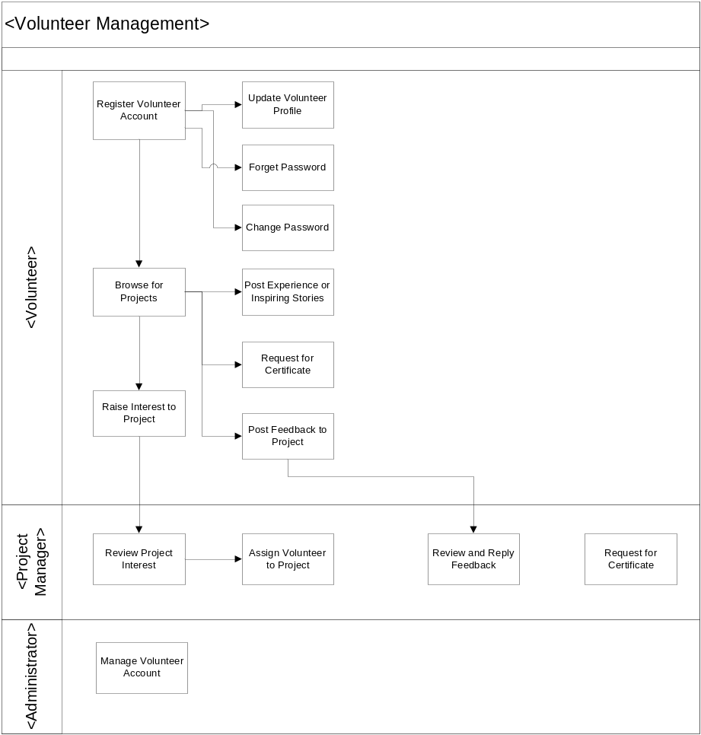
Figure 1 Volunteer Management Business Workflow Overview

Register Volunteer Account
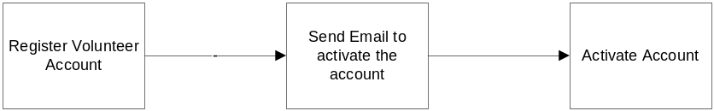
- Upon interesting to become a volunteer, a user can register as the volunteer by signing up for a volunteer account through System. The following information are required to be input into the System for registration of a volunteer account:
- Email Address
- Password
- The System shall verify that the email account has not already existed in the System before creation of the account. An email notification will be sent to the volunteer email’s address for the account activation.
- The volunteer is required to activate the user account via and hyperlink that was sent in the email notification from the System.
- Upon successfully logging into the System, the volunteer account is then activated. The volunteer may then proceed to update his/her profile.

Update Volunteer Profile

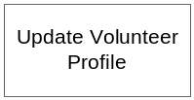
- The System shall allow the volunteer to update the following information for an activate account.
  - Title( Mr. , Mrs. , Ms, Dr, Other)
  - First Name
  - Last Name
  - Address
  - Country
  - Email Address (Read Only Field)
  - Phone(Home)
  - Phone(Mobile)
  - Date of Birth
  - Hobbies/ Interests
  - Special Skills
  - Qualifications attained (Education)
  - Qualifications attained (Others)
  - Languages
  - Volunteer Interests (Admin, Befriending, Events (organizing), General Services, IT, Research, Marketing/Publicity, Skilled Services, Others)
  - Join Date(Read Only)

Forget Password
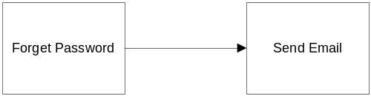
- The System shall generate a new password when the volunteer forget his or her password. It shall allow the user to input the
  - Email Address
- If the email address is valid (i.e. the email address is the same as the registered email address in the system), an email notification will be sent to the volunteer together with the newly generated password.
- If the email address is invalid, the system shall still send the email as above without notifying that wrong email has been entered because unauthorised personnel may know that it is an incorrect email address, which may introduce more trails of attempt to reset password.

Change Password
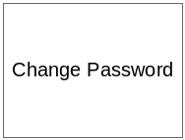
- The System shall allow the volunteer to change password at anytime.
  - Email Address
  - Old Password
  - New Password
  - Confirm New Password
  - An error message will be displayed if
  - Email address and old password is not valid
  - New password and confirm new password are not same

Browse for Project

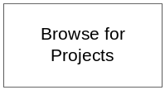
- After logging in to the System by the volunteer, the System shall display all the projects, either:
  - All the projects that the volunteer joined or that he is currently joining
  - All the active projects which has enough team members and which is currently progress.
  - All the active projects which has insufficient team members
  - The System shall display the project information and
  - The request status to join to the project
    - Requested (Request the project to join)
    - Withdraw (Withdraw from the project by Volunteer)
    - Rejected (Request to join the project is rejected by PM. The volunteer can see the reason by PM)
    - Unsuccessful (There is more than one request to join the projects for the overlap period. When the volunteer is accepted by one project, the other project request for the overlap period will be reflected as Unsuccessful. The volunteer can see the comment which is auto generated by the system)
- All the past project from 2 months ago or for a specified period which is defined by the volunteer

Raise Interest to Project

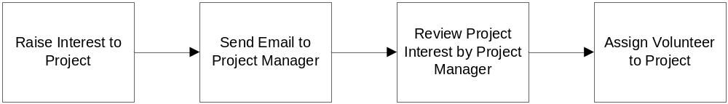
- For the active projects which are not started yet and which require more volunteers, the volunteer can raise the interest to the Project Manager. The volunteer can raise more than one project at a time.
- The System shall send the email to the relevant project manager when there is the interest request to the project.
- When the project request status is in Requested which means that the PM hasn’t decided to let the volunteer join the project, if the volunteer want to cancel his request, the System shall allow canceling it.
- The System shall send the email to the relevant project manager about his cancellation

Review Project Interest by volunteer and Assign Volunteer to Project

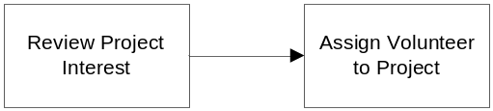
- The System shall allow the project manager to review the list of requested volunteer who want to join to a specific project. The System shall display the following information of the volunteer:
  - Title( Mr. , Mrs. , Ms, Dr, Other)
  - First Name
  - Last Name
  - Address
  - Country
  - Age
  - Hobbies/ Interests
  - Special Skills
  - Qualifications attained (Education)
  - Qualifications attained (Others)
  - Languages
  - Volunteer Interests (Admin, Befriending, Events (organizing), General Services, IT, Research, Marketing/Publicity, Skilled Services, Others)
  - Availability Status
  - Join Date (Read Only)
- If the volunteer submit two projects which falls the same or overlap duration and one project manager accepts him or her to join his project, the next project manager will see his availability status as Occupied and the PM shall not be able to assign him to his project.
- The project manager can accept/reject the volunteer request.
- When the project manager accept a volunteer request to join his project,
  - The System shall check if there is the other project request which fall the same period. If there is the request for the same project period, the project request status will be updated from Requested to Unsuccessful
  - The System will send the notification email to that volunteer about approval.
- When the project manager reject a volunteer request to join his project,
  - The project request status will be updated from Requested to Rejected
  - The System will send the notification email to that volunteer about rejection.

Post Feedback to Project
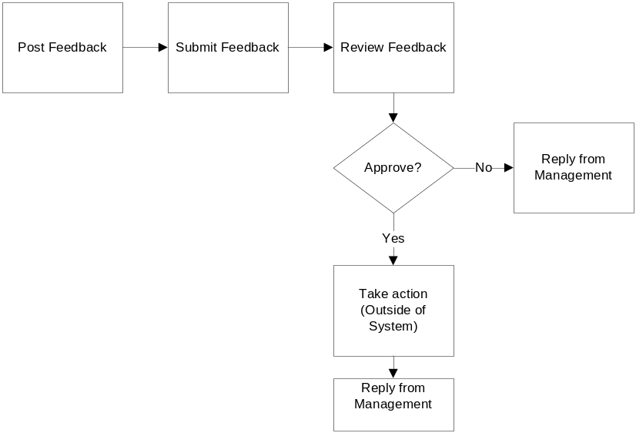
- The System shall allow the volunteer to post the feedback/suggestion to all kind of projects (Ongoing/Currently Joined/Past Projects). The System will provide the user to input the feedback/suggestion.
- The System shall allow that feedback to be modified or deleted by the feedback poster before the PM approval.
- The System shall not allow that feedback to be modified or deleted by the feedback poster after the PM approval.
- The System shall display all the feedbacks of a project to all volunteers but the System shall allow only the feedback owner to modify/delete it.

Post Experience or Inspiring Stories


- The System shall allow the volunteer to post their past experience or inspiring stories to the past projects. The System will provide the user to input the experience or inspiring stories.
- The System shall allow that experience or inspiring stories to be modified or deleted by the owner.

Review and Reply Feedback

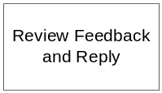
- The PM should check the posted feedback regularly for the projects he wants. The System shall allow the PM to view the feedback and approve/reject the feedback.(Note. To follow up the feedback/suggestion is the outside of the System.)

Request for Certificate
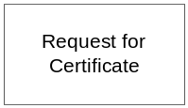
- The System shall allow sending the request for the Project Participation Certification to the System admin.
- The request can be done by two roles:
  - Project Manager (When the project is finished, project manager can send request the certificate for the whole team)
  - Volunteer ( When the volunteer want the certificate for a particular project he joined, volunteer can send the request)
- The System shall send the notification email to all the people with System admin role.

Manage Volunteer Account
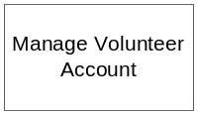
- The System shall allow the System admin for the viewing of volunteer details .These records will consist of:
  - Title( Mr. , Mrs. , Ms, Dr, Other)
  - First Name
  - Last Name
  - Address
  - Country
  - Email Address (Read Only Field)
  - Phone(Home)
  - Phone(Mobile)
  - Date of Birth
  - Hobbies/ Interests
  - Special Skills
  - Qualifications attained (Education)
  - Qualifications attained (Others)
  - Languages
  - Volunteer Interests (Admin, Befriending, Events (organizing), General Services, IT, Research, Marketing/Publicity, Skilled Services, Others)
  - Activity status (Active/Inactive)
  - Join Date
- The System shall allow to activate/deactivate the volunteer account
- The System shall have the ability to retrieve the volunteer records, based on name, Email address or age group, but not to amend or delete them

Staff Management
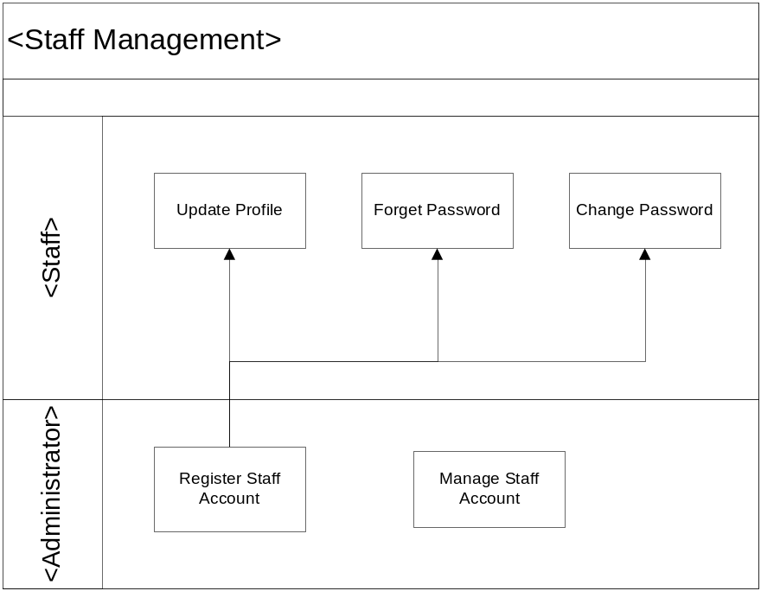
Figure 2 Staff Management Business Flow Overview

Register Staff Account


- When new staff joins organisation, if he/she needs to access VMS, System Administrator shall register account for new staff. Upon creating a new staff, the System shall enable details of the new staff to be input to the System. These details shall be:
  - Title
  - First Name
  - Last Name
  - Email Address
  - Job Title
  - Role
- Then System shall send notification email to staff with user name and password to access VMS.

Update Staff Profile
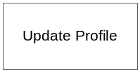
- The System shall the following staff account details to be modified at any time after getting the account. The System shall enable details of the existing staff to be input/modify to the System. These details shall be:
  - Title( Mr. , Mrs. , Ms, Dr, Other)
  - First Name
  - Last Name
  - Address
  - Country
  - Email Address (Read Only Field)
  - Phone(Home)
  - Phone(Mobile)
  - Date of Birth
  - Job Title
  - Role(Read Only Field)
  - Join Date

Forget Password

- The System shall to get the System generated password when the staff forgets his or her password. It shall allow the staff to input the
  - Email Address
- If the email address is valid (i.e. the email address is the same as the registered email address in the system), an email notification will be sent to the volunteer together with the newly generated password.
- If the email address is invalid, the system shall still send the email as above without notifying that wrong email has been entered because unauthorised personnel may know that it is an incorrect email address, which may introduce more trails of attempt to reset password.

Change Password

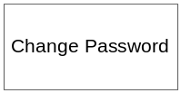
- The System shall allow the staff to change his/her preferred password at anytime.
  - Email Address
  - Old Password
  - New Password
  - Confirm New Password
- The error message appear if
  - Email address and old password is not valid
  - New password and confirm new password are not same

Manage Staff Account

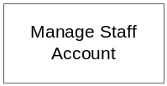
- The System shall allow the System admin for the maintenance of staff detailed .These records will consist of:
  - Title( Mr. , Mrs. , Ms, Dr, Other)
  - First Name
  - Last Name
  - Address
  - Country
  - Email Address (Read Only Field)
  - Phone(Home)
  - Phone(Mobile)
  - Date of Birth
  - Job Title
  - Role
  - Join Date
  - Activity status (Active/Inactive)
- The System shall allow updating the staff records including assigning role. The System shall allow assigning more than one role to the staff.
- The System shall have the ability to retrieve the staff records, based on name, Email address but not to amend or delete them.
- The System shall allow activating or deactivating account when the staff leave the organisation or rejoin the organisation.

Project Management
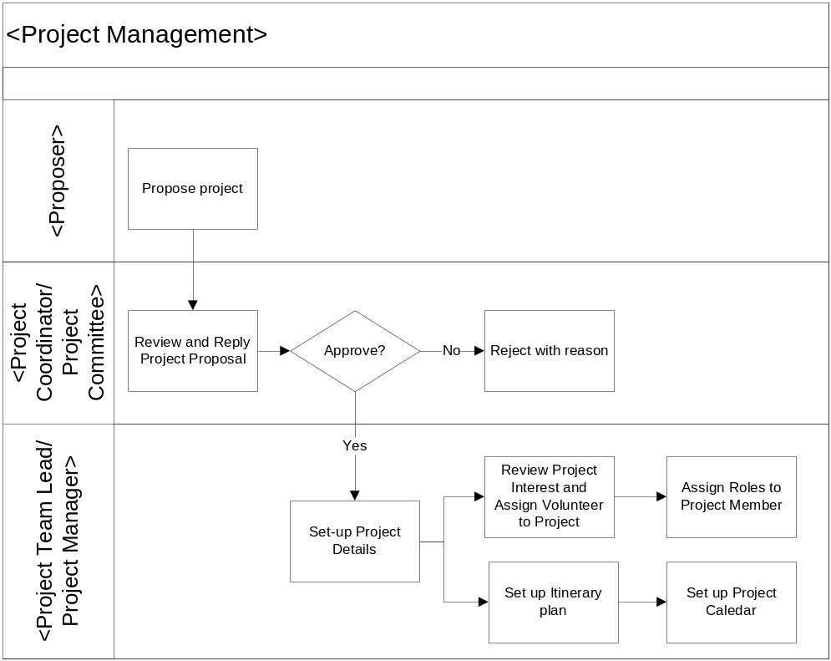
Figure 3 Project Management Business Flow Overview

Propose Project

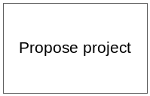
- The System shall allow the volunteer or internal staff to propose the project to the organisation. The System shall accept the following details of the proposal.
  - Project Name
  - Project Description
  - Country
  - Location
  - Estimated Duration
  - Proposer
  - Created Date
- The System shall allow the volunteer or internal staff to view the proposal records and the status of the project proposal. The submitted proposal will have the following status:
  - Submitted (When the proposal is submitted to the Project Coordinator)
  - Rejected (When the proposal is rejected by the Project Coordinator)
  - Approved (When the proposal is approved by the Project Coordinator)
- The System shall also allow these details to be recalled and displayed.
- The System shall also allow these details to be modified by the owner before the approval.
- The System shall send the email to Project Coordinator about the submitted proposal. The Project Coordinator will review the Project Proposal with the Project Committee and this will be outside of the System.

Review and Reply Project Proposal

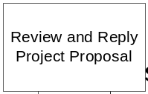
- The System shall allow the project coordinator to review the Project Proposal information. In fact, the project coordinator will review the proposal with the relevant project committee members and which is outside of the System.
  - Project Name
  - Project Description
  - Country
  - Location
  - Estimated Duration
  - Proposer
  - Created Date
- The System shall allow project coordinator approving/rejecting the project proposal according to the decision of the project committee. The System will send the notification email to the proposer about the approval or rejection by the project coordinator.

Setup Project Details

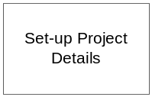
- Once the propose project is approved by the project coordinator, the project status will change to Approved and by that time, it is assumed that the project is set up.
- However, some projects are not proposed by volunteer or internal staff. Therefore, the relevant project manager can setup the project straight away without passing through the proposal project. The System shall enable details of the new project to be input to the System by the project manager. These details shall be:
  - Project Name
  - Project Description
  - Project Country
  - Project Location
  - Project Start Date
  - Project End Date
  - Project Status (Coming, On Going, Closed)
  - Project Manager

Manage Projects

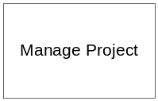
- The System shall allow all the staff with project manager role to view the project based on:
  - Project Name
  - Project Description
  - Country
  - Project Location
  - Start Date
  - Project Status(Coming, On Going, Closed)
  - Project Manager
  - Created Date
  - Project Progress Percentage
- The System shall allow the relevant project manager to modify his/her projects
  - Project Name
  - Project Description
  - Project Location
  - Country
  - Start Date
  - End Date
  - Project Status(Coming, On Going, Closed)
  - Created Date(Read Only)
  - Project Progress Percentage
- The System shall not allow the PM to delete the project.

Review Project Interest by Volunteer and Assign Volunteer to the Project

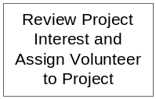
- Refer to 3.1.2.7

Assign Roles to Project Member


- The System shall allow the PM to assign roles to project members.

- The System shall also send the notification email to assigned volunteer.

Setup Project Calendar

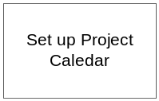
- After setting up the Itinerary Plan in section 3.1.5, the PM can continue with setting up the project calendar. The System shall allow the creation and maintenance of details project calendar.

- Upon successful setup of the Itinerary Plan 3.1.5, the PM can continue to setup the project calendar by referencing to the Itinerary Plan. The system shall allow creation and maintenance of the calendar. The following are required for the setup of the each calendar event:
  - Event Name (Mandatory)
  - Event Description (Mandatory)
  - Event Location (Mandatory)
  - Event Start Date and Time (Mandatory)
  - Event End Date and Time (Mandatory)
  - Attendees (Mandatory)
  - Remarks (Optional)

- Upon successful creation of the event, the user can choose whether to publish this event to the team members.

- Events that are selected to be published to the team members will be published to each team members’ calendar. They will be able to view it upon logging into the system

Itinerary Management

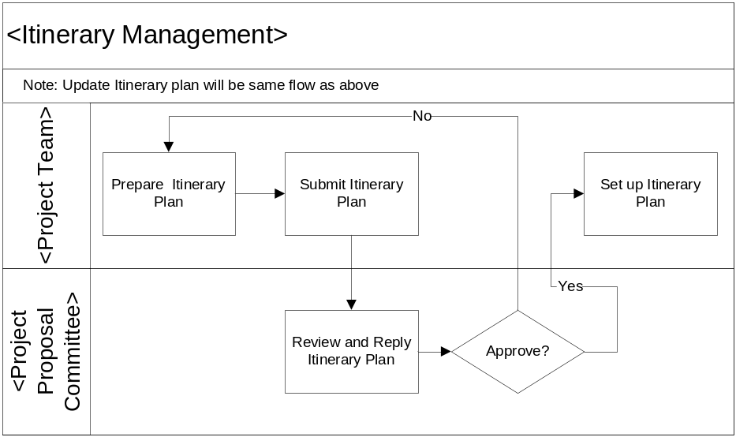
Figure 4 Itinerary Management Business Flow Overview

Prepare Itinerary Plan

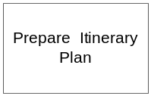

- The project itinerary plan is made up with project itinerary items. The project itinerary item represents the phase/task within a project.
- After setting up the project details, the System shall enable details of the project itinerary item to be put to the System by project manager. These details shall be:
  - Project ID
  - Task ID
  - Task Order No
  - Task Name
  - Task Description
  - Task Duration
  - Task Status
    - Drafting (Before submitting the Itinerary Plan)
    - Submitted (After submitting the Itinerary Plan)
    - Approved (After Approving the Itinerary Plan)
    - Rejected (After Rejecting the Itinerary Plan, Note: The System shall allow the PM to modify the Itinerary item with Rejected status and let them submit again after modification)
- The System shall also allow these details of project itinerary item to be recalled or displayed.
- The System shall also allow these details to be modified.
- The System shall also allow project itinerary item records to be deleted if it is needed.

Submit Itinerary Plan

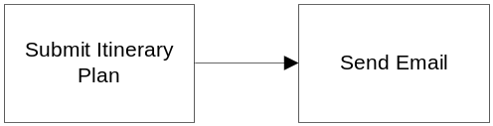
- After preparing the itinerary Plan, the System shall allow to submit the itinerary plan to the project coordinator. The Itinerary Plan details will be:
  - Project ID
  - Approving Officer for Itinerary Plan / Project Coordinator. The System shall assist to show the list of the staffs with Project coordinator role in dropdown to choose.
  - Total Project Duration
  - Itinerary Plan Status
    - Drafting (Before submitting the Itinerary Plan)
    - Submitted (After submitting the Itinerary Plan)
    - Approved (After Approving the Itinerary Plan)
    - Rejected (After Rejecting the Itinerary Plan)
- Once the Itinerary Plan is submitted to a project coordinator/ Approving officer, the System shall not allow modifying the project itinerary plan and itinerary items inside the plan.
- The System shall send the notification email to the selected project coordinator for the submission of project itinerary plan

Review and Reply Itinerary Plan


- Upon receiving the notification email for project itinerary plan submission, the project coordinator will review it with the project committee and which is outside of the System.
- The System shall allow the project coordinator to approve or to reject with the reason to the submitted project plan based on the project committee decision.
- Upon approval or rejection by project coordination, the System shall send the notification email to the PM who submits the itinerary plan.
- (Note: Once the project itinerary plan is approved in the System, it is assumed that the project itinerary plan is confirmed and setup in the System. PM cannot modify it anymore)

Reporting

Volunteer Report
- The System shall allow generating Volunteer Report. The report shall present the following data:
  - Volunteer Name
  - The list of projects he/she has joined and is joining
  - Project Name
  - Project Start Date
  - Project End Date
  - Role in Project

Project Report
- The System shall allow generating Project Report. The System shall allow the Project Coordinator or PM to generate the project list by
  - Project’s start date which between user’s selected date
  - Project status
  - Project Manager
  - The report shall present the following data:
  - Project Name
  - Project Location
  - Country
  - Start Date
  - End Date
  - Project Status(Coming, On Going, Closed)
  - Created Date(Read Only)
  - Project Progress Percentage

Certificate Management

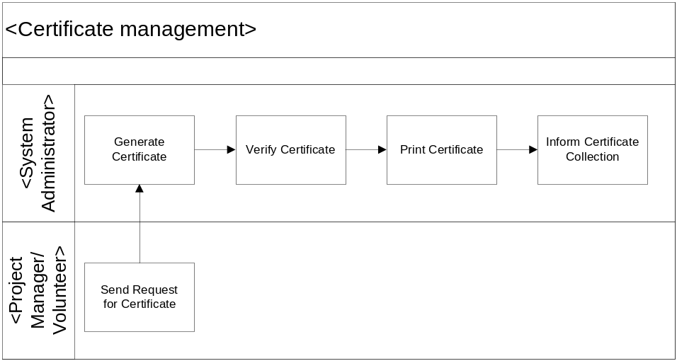
Figure 5 Certificate Management Business Flow Overview

Generate Certificate

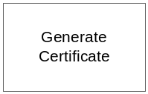
- When the volunteer or project manager request for the certificate, all the staff with System administrator roles will receive the notification email. One of the System administrators will handle the request.
- The System shall allow the System admin to generate the certificate based on:
  - Whole Project (for all project members)
  - A specific project member

Verify Certificate

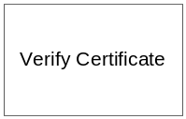
- The system shall generate the certificate to the one specific location of the user machine.
- The user can verify the certificates in their convenient time before printing out them and it is outside of the system.

Print Certificate



- The System then allows the System admin to print the generated certificates associated with a specific project and team members. The certificate content will be:
  - Project Name
  - Volunteer Name
  - Certificate Content
  - Generated Date
  - (Note: Informing for the certificate collection will be outside of the System)

System Control Panel
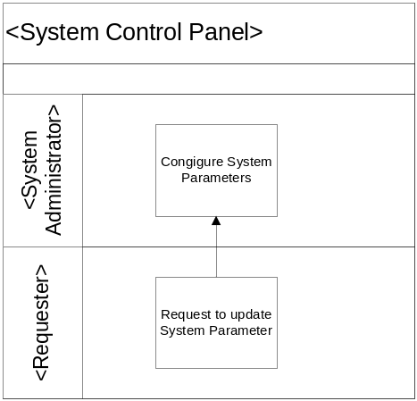
Figure 6 System Control Panel Business Flow Overview

Configure System Parameters

- The system shall allow update or configure of predefined system parameters to be made by the administrator.
- The set of predefined parameters shall be loaded into the system before commencement on the usage of the system.
- The full list of pre-defined system parameters shall be gathered during the development cycle of the system as the parameters are required to be used by the system.
- An example of a system parameter:
- Searching of records using a Date Range parameters. E.g. Start Date and End Date. The date range cannot be more than N number of months, where N is a system parameter which can be configured through this System Parameter section.

User Interface Requirements
- Web Page should be user friendly with minimal steps required.
- Web page should not include typos, no misalignment.
- Master page/common theme will be applied to all major pages: popup page/message page will not needed master page/theme.
- UI will have to compatible with most common browser Internet Explorer and FireFox

OPERATIONAL and Quality REQUIREMENTS

Operating Environment
The VMS system shall operate in Internet and Intranet environment. Server system shall operate on Microsoft Window 2008 Standard Edition. System run time environment should be JRE 1.6 and above. Web server shall be Apache HTTP Server 2.2.7. Two Application servers/ application instances shall be used Apache Tomcat 6.0+. Based on the application work load, a number of instances can be added up without the software modification. All the application data shall be stored on Microsoft SQL Server 2008 and above. Minimum requirement for user’s web browser/ client shall be Internet Explorer 6.0 +, Firefox 2.0.+.

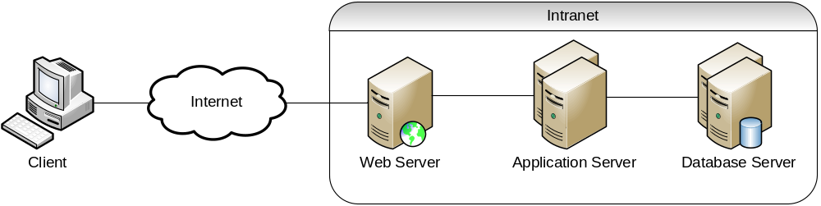
Figure 7. Logical System Diagram

Development Constraints
The software shall be designed using the Rational Unified Process. Integrated development environment shall be Eclipse Java EE IDE for Web Developers. JDK 1.5+ shall be used for software development. Apache Ant1.8+ shall be used for source compilation.

Development Platform and Frameworks
Hibernate 3 for database and object mapping , Spring 2.0 for a layered Java/J2EE application platform, Direct Web Remoting Java library that enables Java on the server and JavaScript in a browser to interact and call each other as simply as possible. The YUI Library graphical user interface shall be used for rich user interface.

Performance
The system shall maintain an average of 2 seconds to response to every DWR request from Intranet user or Internet user. The system shall maintain an average of 5 seconds to response to every http request from intranet user or internet use. (Based on two instance servers)

Reliability
The combined hardware and software system shall have 99% reliability. In particular during a 24 hour running period the system should not be unavailable for a period longer than 2 hours in total.

Availability
The system shall be available 24 hours a day, 7 days / 167.5 hour a week with 99% availability per year. The application servers and database servers shall offline 30 minutes for scheduled maintenance every Sunday on the second week of the month.

Capacity and Expandability
The design of the system shall be flexible in order to allow modifiability of the system.

Security
The VMS system shall used Spring Security for access control. User information such as user name and password shall store in VMS database. Password encryption shell implemented using SHA-1. VMS require all users to enter a valid password to logon to the system. Each user will be granted access only to functions that are compatible with their responsibilities/ role.

Future Growth
The system should be designed such that only minimal changes are required to modify it to meet the requirements of the volunteer management system.

ANNEX A Amendment History

This is a record of all amendments made to the Document.
Version | Chapter / Section | Page No | Notes of Amendments or Changes

